**An Efficient Approach to Column Selection in HPLC Method Development**

**Introduction**

***Common Mistakes in Method Development:***

• Inadequate Formulation of Method Goals

• Little Knowledge of Chemistry of Analyte Mixture

• Use of the First Reversed Phase C18 Column Available

• Trial and Error with Different Columns and Mobile Phases

***These Mistakes Result In:***

• Laborious, Time-consuming Development Projects

• Methods that Fail to Meet the Needs of the Analyst

**HPLC Method Development - A Proposed Procedure**

***At Your Desk***

• Define your knowledge of the sample

• Define your goals for the separation method

• Choose the columns to be considered

***In the Laboratory***

• Choose the initial mobile phase chemistry

• Choose the detector type and starting parameters

• Evaluate the potential columns for the sample

• Optimize the separation conditions (isocratic or gradient) for the chosen column

• Validate the method for release to routine laboratories

**Choosing the Appropriate HPLC Column Should Be Based Both Upon Knowledge of the Sample and Goals for the Separation**

***Benefits of this Approach Include:***

• Small initial time investment

• Big time savings in the HPLC laboratory

• More “informed” approach to column selection

• More efficient than “trial and error” approach

**Knowledge of the Sample Influences the Choice of Column Bonded Phase Characteristics**

***Knowledge of the Sample***

• Structure of sample components?

• Number of compounds present?

• Sample matrix?

• pKa values of sample components?

• Concentration range?

• Molecular weight range?

• Solubility?

• Other pertinent data?

***Column Chemistry*** :(bonded phase, bonding type, endcapping, carbon load)

**Goals for the Separation Influence the Choice of Column Particle Physical Characteristics**

***Goals for the Separation***

• Max. resolution of all components?

• Partial resolution?

• Fast analysis?

• Economy (low solvent usage)?

• Column stability and lifetime?

• Preparative method?

• High sensitivity?

• Other goals?

***Column Physics*** :(particle bed dimensions, particle shape, particle size, surface area, pore size)

**Choosing the Bonded Phase**

Draw the molecular structures for all known components of the mixture. Identify the two compounds whose structures are the most similar.

e.g.:



Prednisolone Prednisone

Use the results of the structural comparison to select a bonded phase showing optimal selectivity for these two molecules. In this case consider using a silica column (no bonded phase) for its ability to retain polar solutes through hydrogen bonding.

**Choosing the Bonded Phase**

Examples of bonded phases used for HPLC packing media:

**C18 or Octadecylsilane (ODS)**

**Very nonpolar** - Retention is based on London (dispersion) interactions with hydrophobic compounds.

*Example Alltech Phase: Alltima™ C18*

 

**Choosing the Bonded Phase**

**Phenyl**

**Nonpolar - Retention is a mixed mechanism of hydrophobic and p - p interactions.**

***Example Alltech Phase: Platinum™ Phenyl***



**Cyanopropyl**

**Intermediate polarity - Retention is a mixed mechanism of hydrophobic, dipole-dipole, and p - p interactions.**

***Example Alltech Phase: Alltima™ CN***

** **

***As a practical example, to separate toluene and ethyl benzene:***

**• Note a difference of one -CH2- unit**

**• Choose a C18 bonded phase for retention by hydrophobicity**

**• Maximize hydrophobic selectivity with a high silica surface area, high carbon load material like Alltima C18**



**Toluene Ethyl Benzene**

**Choosing the Particle Physical Characteristics**

***Use the Column Selection Chart***

**• Use “default” column as starting point**

**• Match up method goals with individual particle physical characteristics**

**• Change only those particle parameters that affect the method goals**

**• Recognize the “optimum” column as a possible compromise**

***Example:***

**Sample Type: hydrophobic compounds**

**Method Goal: highest resolution**

**Choosing the Particle Physical Characteristics**

***Example:***

**Sample Type: hydrophobic compounds**

**Method Goal: highest resolution**

**Column Selection Chart:**

**Default Column Optimum Column†**

**Column Bed Dimensions 150 x 4.6mm 250 x 4.6mm**

**Particle Size 5µm 3* or 5µm**

**Surface Area 200m2/g >200m2/g**

**Pore Size 100Å 100Å**

**Carbon Load 10% 16 - 20%**

**Bonding Type Monomeric Mono- or Polymeric**

**Base Material Silica Silica**

**Particle Shape Spherical Spherical**

**\* mobile phase backpressure may be excessive**

**† Optimum Column: Alltima C18™, 5µm, 250 x 4.6mm (Part No. 88056)**

**Choosing the Particle Physical Characteristics**

**Column Dimensions**

**•** Length and internal diameter of packing bed

***Particle Shape***

**•** Spherical or irregular

***Particle Size***

• The average particle diameter, typically 3-20µm

***Surface Area***

**•** Sum of particle outer surface and interior pore surface, in m2/gram

**Choosing the Particle Physical Characteristics**

**Pore Size**

• Average size of pores or cavities in particles, ranging from 60-10,000Å

***Bonding Type***

• Monomeric - single-point attachment of bonded phase molecule

• Polymeric - multi-point attachment of bonded phase molecule

***Carbon Load***

• Amount of bonded phase attached to base material, expressed as %C

***Endcapping***

• “Capping” of exposed silanols with short hydrocarbon chains after the primary bonding step

**Effect on chromatography**

***Column Dimension:***

**• Short (30-50mm) - short run times, low backpressure**

**• Long (250-300mm) - higher resolution, long run times**

**• Narrow (≤ 2.1mm) - higher detector sensitivity**

**• Wide (10-22mm) - high sample loading**

**Particle Shape:**

**Effect on chromatography**

**Spherical particles offer reduced back pressures and longer column life when using viscous mobile phases like 50:50 MeOH:H2O.**

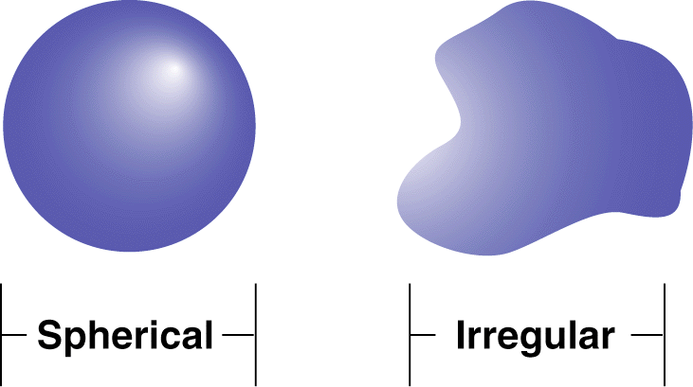

**Particle Size: Effect on chromatography**

**Smaller particles offer higher efficiency, but also cause higher backpressure. Choose 3µm particles for resolving complex, multi-component samples. Otherwise, choose 5 or 10µm packings.**

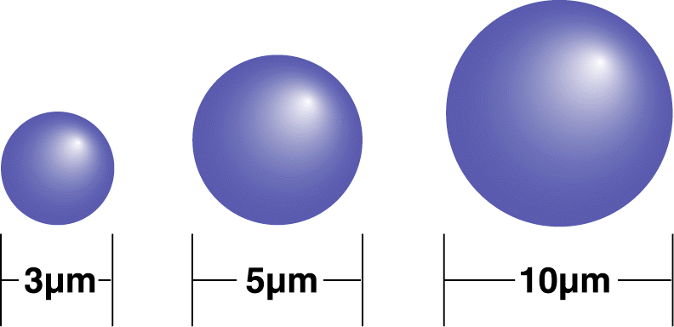

**Surface Area**

**Effect on chromatography**

High surface area generally provides greater retention, capacity and resolution for separating complex, multi-component samples. Low surface area packings generally equilibrate quickly, especially important in gradient analyses.

High surface area silicas are used in Alltech’s Alltima™, Adsorbospherel® HS, and Adsorbosphere® UHS packings. Low surface area silicas are used in Alltech’s Platinum™, Econosphere™, and Brava™ packings.



**Pore Size**

**Effect on chromatography**

Larger pores allow larger solute molecules to be retained longer through maximum exposure to the surface area of the particles. Choose a pore size of 150Å or less for sample MW ≤ 2000. Choose a pore size of 300Å or greater for sample MW > 2000.



**Bonding Type**

**Effect on chromatography**

Monomeric bonding offers increased mass transfer rates, higher column efficiency, and faster column equilibration.





Polymeric bonding offers increased column stability, particularly when highly aqueous mobile phases are used. Polymeric bonding also enables the column to accept higher sample loading.

**Carbon Load**

**Effect on chromatography**

Higher carbon loads generally offer greater resolution and longer run times. Low carbon loads shorten run times and many show a different selectivity, as in Alltech’s Platinum line of packings.

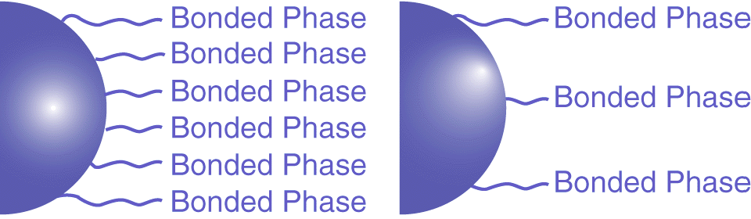

**Endcapping**

**Effect on chromatography**

Endcapping reduces peak-tailing of polar solutes that interact excessively with the otherwise exposed, mostly acidic silanols. Non-endcapped packings provide a different selectivity than do endcapped packings, especially for such polar samples.

Alltech’s Platinum™ EPS packings are non-endcapped to offer enhanced polar selectivity.

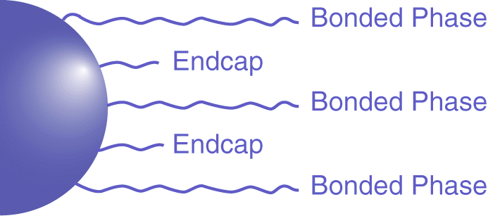

**Conclusion**

In this approach to HPLC column selection, the bonded phase chemistry of the column is chosen on the basis of an analysis of the sample component structures. The physics of the column is chosen according to an analysis of the goals for the separation method. This approach succeeds in predicting unique, optimum bonded phase chemistries and particle bed physical characteristics that are likely to meet the goals for the separation method.